**# Blue Team: Summary of Operations## Table of Contents**

- Network Topology- Description of Targets- Monitoring the Targets- Patterns of Traffic & Behavior- Suggestions for Going Further**### Network Topology** The following machines were identified on the network: - Name of VM 1 - **Operating System**: Linux 3.2-4.9 - **Purpose**: Wordpress Server - **IP Address**: 192.168.1.110 ```

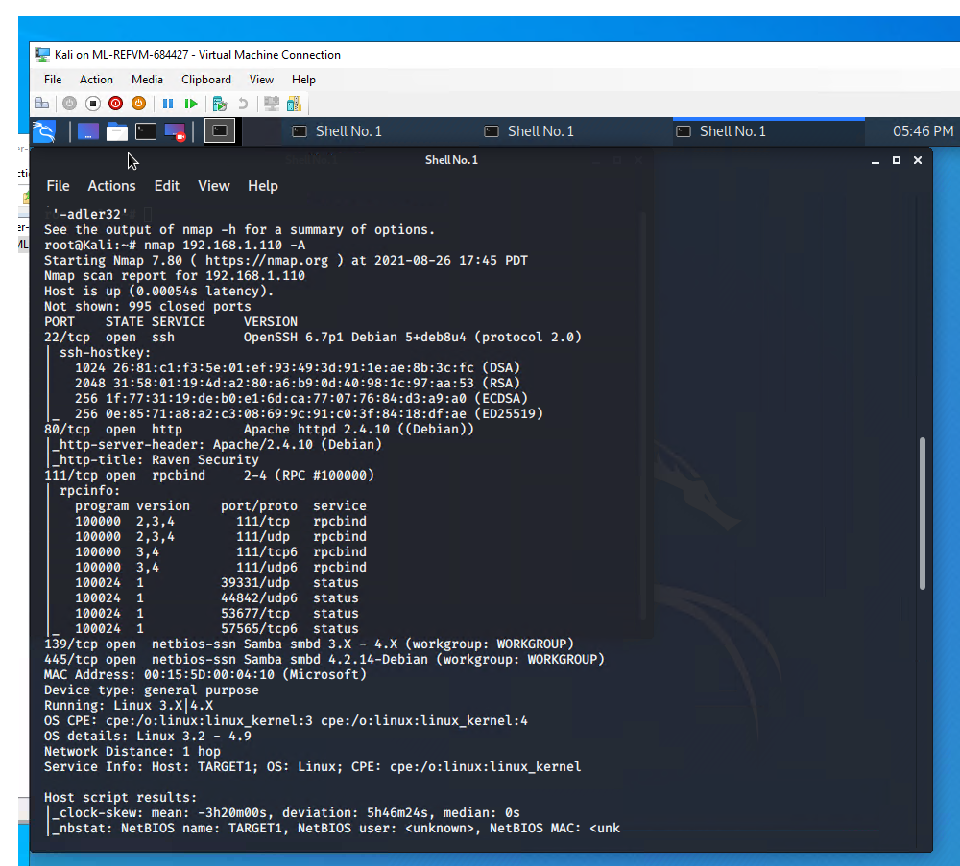 - Name of VM 2 - **Operating System**: Linux 3.2-4.9 - **Purpose**: Wordpress Server - **IP Address**: 192.168.1.115``` ![nmapA2](Images/nmapA2.png) **### Description of Targets The target of this attack was: `Target 1`: 192.168.1.110** Target 1 is an Apache web server and has SSH enabled, so ports 80 and 22 are possible ports of entry for attackers. As such, the following alerts have been implemented:```**#### Name of Alert 1: Excessive HTTP Errors** 'Excessive HTTP Errors' is implemented as follows: - **Metric**: http.response.status.code - **Threshold**: 400 every 5 minutes - **Vulnerability Mitigated**: A brute force attack would generate HTTP error responses. This Watcher alerts if there are an excessive number of HTTP requests in a short period of time - **Reliability**: Based on volume of network traffic, this watcher generates a low number of false positives.``` 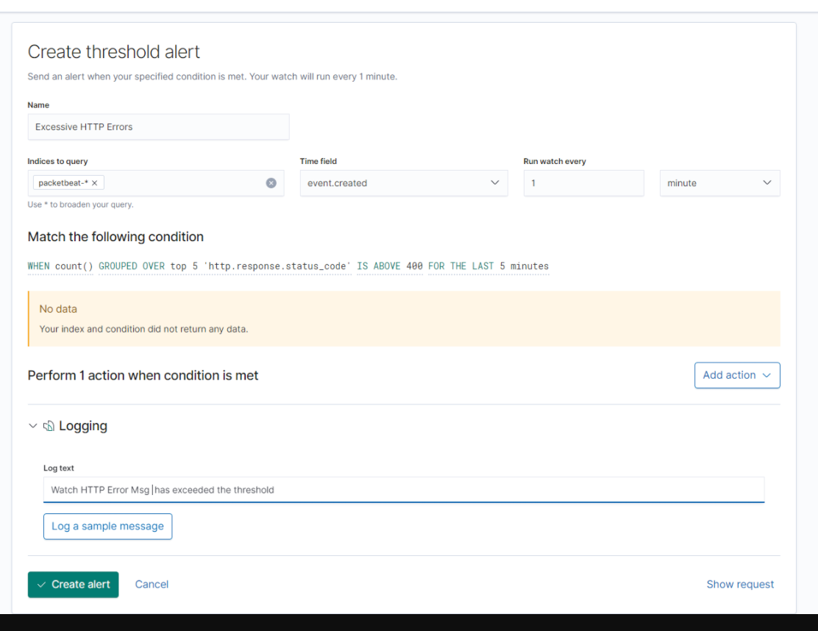

**#### Name of Alert 2: HTTP Request Size** 'HTTP Request Size' is implemented as follows: - **Metric**: http.request.bytes - **Threshold**: 3500 per 1 minute - **Vulnerability Mitigated**: A comparitvely large volume of traffic moving ovewr the system would be unusual and warrant investigation. - **Reliability**: Based on volume of network traffic, this Watcher should not trigger many false positives.```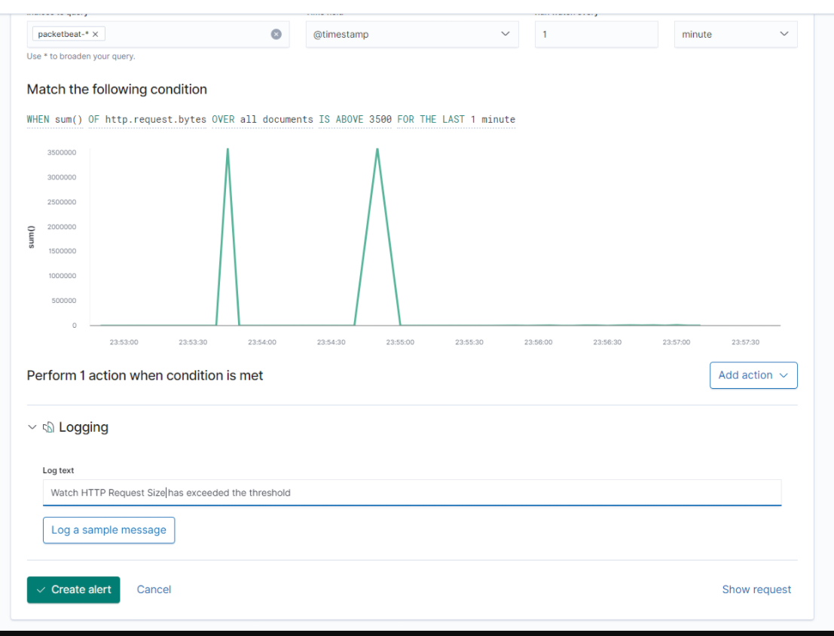

**#### Name of Alert 3: CPU Usage Monitor** Alert 3 is implemented as follows: - **Metric**: system.process.cpu.total.pct - **Threshold**: .5 over 5 minutes - **Vulnerability Mitigated**: If the system CPU is working excessively, it could indicate abnormal processes are occuring on the system which should be investigated as potential threats - **Reliability**: Based on system history, a very low amount of system resources are consumed in the normal course of business, so a spike in utilization would be abnormal. This would make the rate of false positives low``` 